# Homework 2 – Origami Dataset

**Question 2.1**

1. **Using the full dataset on time to manufacture an origami boat:**
   * **Compute the mean (x).**

Mean ($\overline{x}$) = 93.01229167

* + **Compute the median.**

Median = 65.785

* + **Compute the 5th and 95th percentile (P5; P95).**

5th percentile = 13.9935

95th percentile = 230.5155

* + **Compute the 1st, 2nd, and 3rd quartile (Q1; Q2; Q3).**

1st Quartile = 42.845

2nd Quartile = 65.785

3rd Quartile = 116.155

* + **Compute the interquartile range (IQR).**

Interquartile Range (IQR) = 73.31

* + **Compute the sample variance and sample standard deviation (s2; s).**

Sample Variance s2 = 5995.876141

Standard Deviation s = 77.43304296

* + **Create a histogram with appropriate bins.**

|  |  |
| --- | --- |
| Bin | Frequency |
| 0 - 50 | 15 |
| 51 - 100 | 16 |
| 101 - 150 | 8 |
| 151 - 200 | 2 |
| 201 - 250 | 5 |
| 251 - 300 | 1 |
| 301 - 350 | 0 |
| 351 - 400 | 1 |

1. **For each team manufacturing at least 5 origami boats, create a box-and-whiskers plot where whiskers show extremes within 1.5 IQR. For example, if three teams produced at least 5 boats each, your answer should have three separate box plots.**
   * Blue Team Box and Whiskers Plot

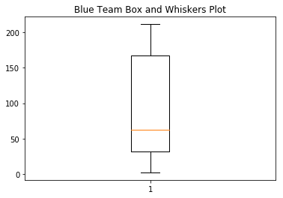

|  |  |
| --- | --- |
| Minimum | 2.36 |
| Q1 | 32.2325 |
| Median | 62.29 |
| Q3 | 166.62 |
| Maximum | 211.21 |
| Mean | 90.34666667 |
| Range | 208.85 |

* + Orange Team Box and Whiskers Plot

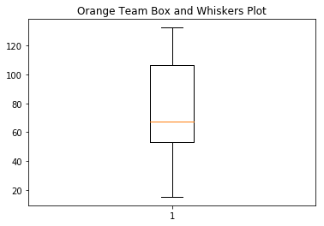

|  |  |
| --- | --- |
| Minimum | 15.17 |
| Q1 | 53.16 |
| Median | 67.32 |
| Q3 | 106.87 |
| Maximum | 132.61 |
| Mean | 74.83307692 |
| Range | 117.44 |

* + Red Team Box and Whiskers Plot

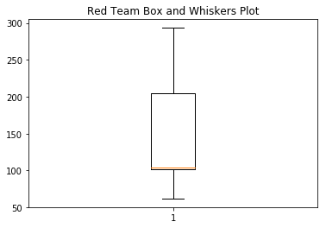

|  |  |
| --- | --- |
| Minimum | 62.01 |
| Q1 | 102.16 |
| Median | 103.52 |
| Q3 | 204.68 |
| Maximum | 293.34 |
| Mean | 153.142 |
| Range | 231.33 |

* + Violet Team Box and Whiskers Plot

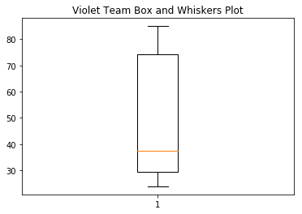

|  |  |
| --- | --- |
| Minimum | 23.84 |
| Q1 | 29.3875 |
| Median | 37.57 |
| Q3 | 74.3275 |
| Maximum | 85.01 |
| Minimum | 23.84 |
| Mean | 49.53833333 |
| Range | 61.17 |

* + Yellow Team Box and Whiskers Plot

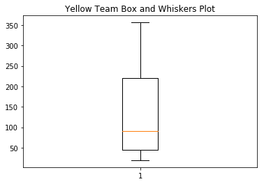

|  |  |
| --- | --- |
| Minimum | 19.21 |
| Q1 | 44.735 |
| Median | 90.76 |
| Q3 | 220.4875 |
| Maximum | 356.32 |
| Mean | 137.4025 |
| Range | 337.11 |

**Question 2.2**

**Flip a coin N = 30 times. Record a \dummy" variable x for each toss indicating an outcome of either heads (1) or tails (0).**

* + **Compute the sample mean (x) and standard deviation (s2).**

Mean ($\overline{x}$) = 0.433333333

Standard Deviation (s2) = 0.504006933

* + **Create a histogram with appropriate bins.**

|  |  |
| --- | --- |
| **Heads** | **Tails** |
| 13 | 17 |

* + **What would you expect the population mean (μ) to be?**

I would expect the population mean to be 0.5 or a value closest to 0.5 (considering heads = 1 and tails = 0).